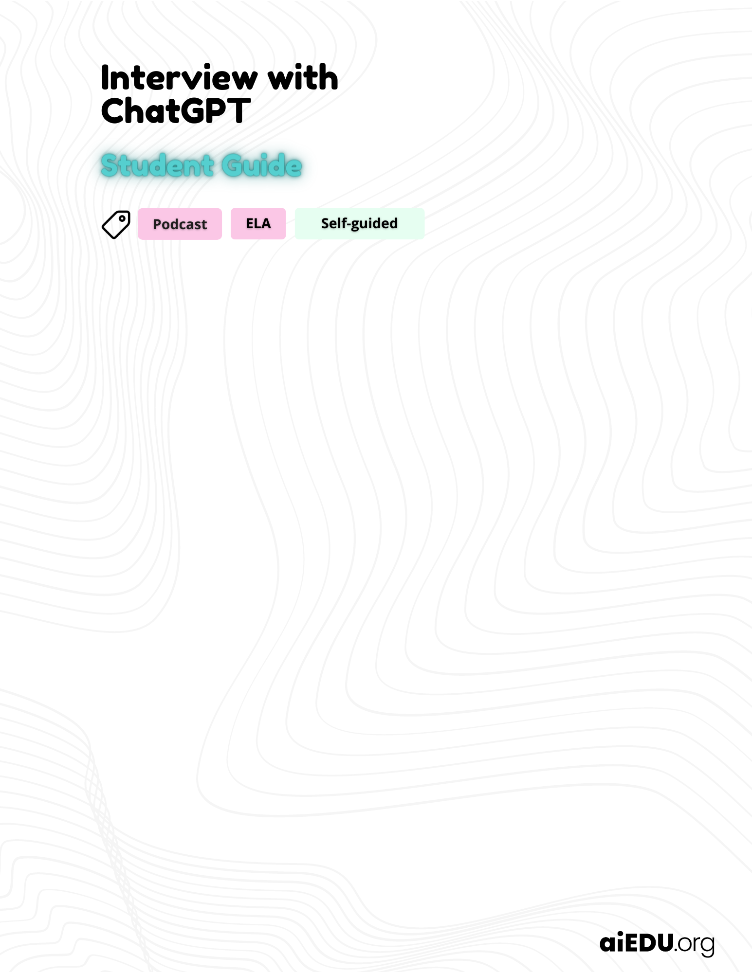

Add your answers in the green boxes below.

Chatting with a computer
 | What do you already know about ChatGPT?

 | The definition of artificial intelligence (AI)
Check out the definition and interesting examples of AI at
🔗 aiedu.org/ai-in-five. Make sure to read the page before moving on.

Testing out ChatGPT
ChatGPT can do a lot of things. It can act like a job interviewer, a football commentator, or a stand up comedian. Here’s an example of a prompt you can try it out with. Your teacher will demonstrate the conversation:

I want you to act like Ron from Harry Potter. I want you to respond and answer like Ron using the tone, manner and vocabulary he would use. Do not write any explanations. Only answer like Ron. You must know all of the knowledge of Ron. My first sentence is "Hi Ron."

How natural does ChatGPT sound and why?

What do you think are ChatGPT’s strengths and weaknesses?

Get comfy with ChatGPT
Try ChatGPT yourself
Your first task is to get familiar with ChatGPT. Test it thoroughly and figure out what it is and isn’t good at. You’ll be interviewing ChatGPT for your podcast later, so it’s important to know what it will and won’t respond well to.

- Get access to ChatGPT.

🔗 Sign up for a free OpenAI account here. Please note that Open AI will require parental consent to create a ChatGPT account if you are under 18.

- Start a few new chats with ChatGPT and test out how it works. Here are some ideas for what to chat with it about:

- Have a conversation with it as if it were your friend
- Ask it to explain something new to you
- Ask it for a top 10 list
- Write a poem or song lyrics with it
- Get some video game recommendations from it
- Ask it about itself
- Pretend to be a pirate and see how it reacts

Choose two interesting conversations you had with ChatGPT and explain what happened in the boxes below.

Which prompts did you try with ChatGPT?

Who does ChatGPT sound like and why do you think that is?

If you finish early…
OpenAI says that ChatGPT can’t answer 7 types of questions, including ones that:
- Require personal opinion or beliefs.
- Are illegal, unethical, or inappropriate.
- Require knowledge beyond my training data.
- Are impossible to answer with the available information.
- Involve speculation or conjecture without evidence.
- Ask for future predictions with complete certainty.
- Violate OpenAI's use-case policy."

Answer the question below using this information.

Why do you think OpenAI created the policy that ChatGPT can’t answer these 7 types of questions? Do you agree with their decision?

Setting up your podcast

Write your podcast script
Directions
With a partner, you will create a podcast interviewing ChatGPT. When you record the podcast, one person will act as the host by reading the questions you come up with. The other person will pretend to be a person, but will actually be reading the responses from ChatGPT.

- Choose a type of person you’d love to interview, like a Minecraft streamer, scientist, makeup vlogger, or politician.
- Write a set of interview questions you’d love to ask that person
- Start a new chat with ChatGPT and prompt it by telling it who you want it to act as
- Ask ChatGPT your questions as if you’re interviewing a real person
- Write the intro and outro scripts so you know how you’ll introduce the interview and reflect on ChatGPT
- Move on to the last section to record your podcast!

Podcast suggestions
- Write a short quiz segment where you ask ChatGPT true/false questions like “True or false: Runescape was created in 2007.”
- Give your podcast a fun name
- Make sure you introduce your guest as a real person

Our interviewee (this is the character that ChatGPT will act as)

Our interview questions

Our intro and outro script (what will you say to introduce the interview and share your reflection at the end?)

Recording your podcast

Record your podcast
Great work writing your podcast script! In this section, you’ll set up your account with Spotify’s Anchor.fm and record your podcast.

- Go to 🔗podcasters.spotify.com or download the mobile app and create an account
- Follow along with this step-by-step video guide to see how you can create a podcast with 🔗 Spotify for Podcasters
  - You can use the mobile app or the web app to create your podcast
- Fill in your Podcast settings to give your podcast a name and cover art
- Create a new episode
- Record clips of your intro, questions and answers, and outro reflection
- Add transitions or music
- Give your episode a name and description
- Publish your podcast and share the Spotify link with friends and family!

Resources
- Don’t forget to watch the 🔗step-by-step video guide to see how to quickly create a podcast episode!
- Check out the 🔗 “Creating an Episode” guide
- 🔗 Check out this guide on How to Start a Podcast, which explains how to record with Spotify for Podcasters
- Explore the 🔗Create guides by Spotify for tips on how to come up with cool ideas, develop a brand for your podcast, and more!

